5.92: (a) There is a contact force n between the man (mass M) and the platform (mass m). The equation of motion for the man is 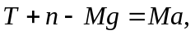 where T is the tension in the rope, and for the platform, 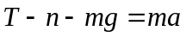. Adding to eliminate n, and rearranging, 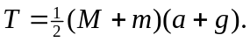 This result could be found directly by considering the man-platform combination as a unit, with mass 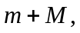 being pulled upward with a force 2T due to the two ropes on the combination. The tension T in the rope is the same as the force that the man applies to the rope. Numerically,
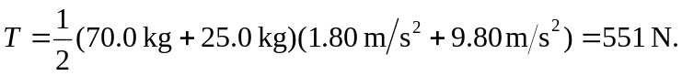
(b) The end of the rope moves downward 2 m when the platform moves up 1 m, so 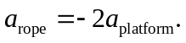 Relative to the man, the acceleration of the rope is 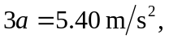 downward.

